Lesson 2 – Procure-to-Pay in SAP



Business Process Overview 2

Procure-to-Pay in SAP 3

Exercise 2 - Create a Vendor 4

Exercise 3 - Create a Purchase Order 11

Exercise 4 - Approve and Release a Purchase Order 14

Exercise 5 - Create a Goods Receipt 17

Exercise 6 - Create a Vendor Invoice 20

# Business Process Overview

Procure-to-Pay (P2P) is one of the most common business processes for large organizations. It encapsulates the entire sequence of events involved in purchasing goods and/or services from an organization’s vendors:

* **Requisition** – someone in the organization requests goods or services and can specify a preferred vendor. This step is optional, and many organizations skip this step.
* **Purchase Order** – the organization submits an order to a vendor for goods or services. If requisitions are used, they can be converted to a purchase order.
* **Goods Receipt** – the organization receives the product or service from the vendor and records the quantities received.
* **Vendor Invoice** – the organization receives an invoice from the vendor and reconciles it against the purchase order and goods receipt(s).
* **Vendor Payment** – after vendor invoice reconciliation, the organization releases a payment to the vendor.

Requisition

Purchase Order

Good Receipt

Vendor Invoice

Vendor Payment

# Procure-to-Pay in SAP

P2P resides in the Accounts Payable sub-module of Financial Accounting. Accounts Payable is typically abbreviated as FI-AP:

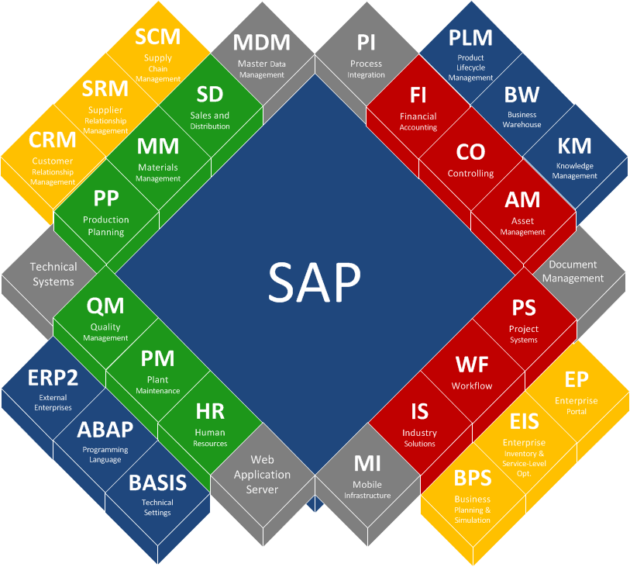

# Exercise 2 - Create a Vendor

In SAP, navigate to transaction **XK01** by typing **XK01** in the transaction launcher (upper left corner of the screen) and hitting **Enter**:

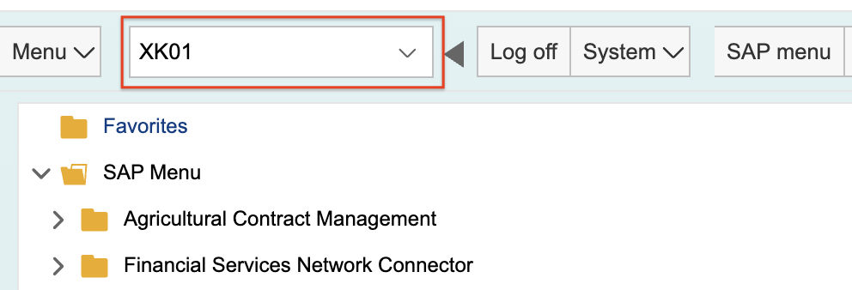

On the screen that displays next, select the following values and then hit **Enter**:

* **Company Code** – click in the field, press F4, and select **3000**
* **Purchasing Organization** – click in the field, press F4, and select **3000**
* **Account Group** – click in the field, press F4, and select **KRED**

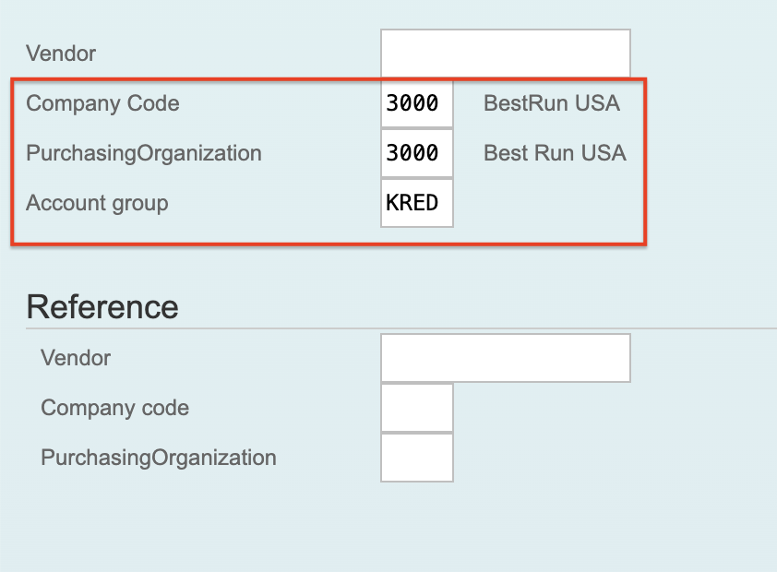

On the screen that displays next, key in the following values and then hit **Enter**:

* **Name** – your last name and then the words **OFFICE SUPPLIES**
* **Search Term** – your last name
* **Street Address** – a valid street address that **IS NOT** personally identifiable

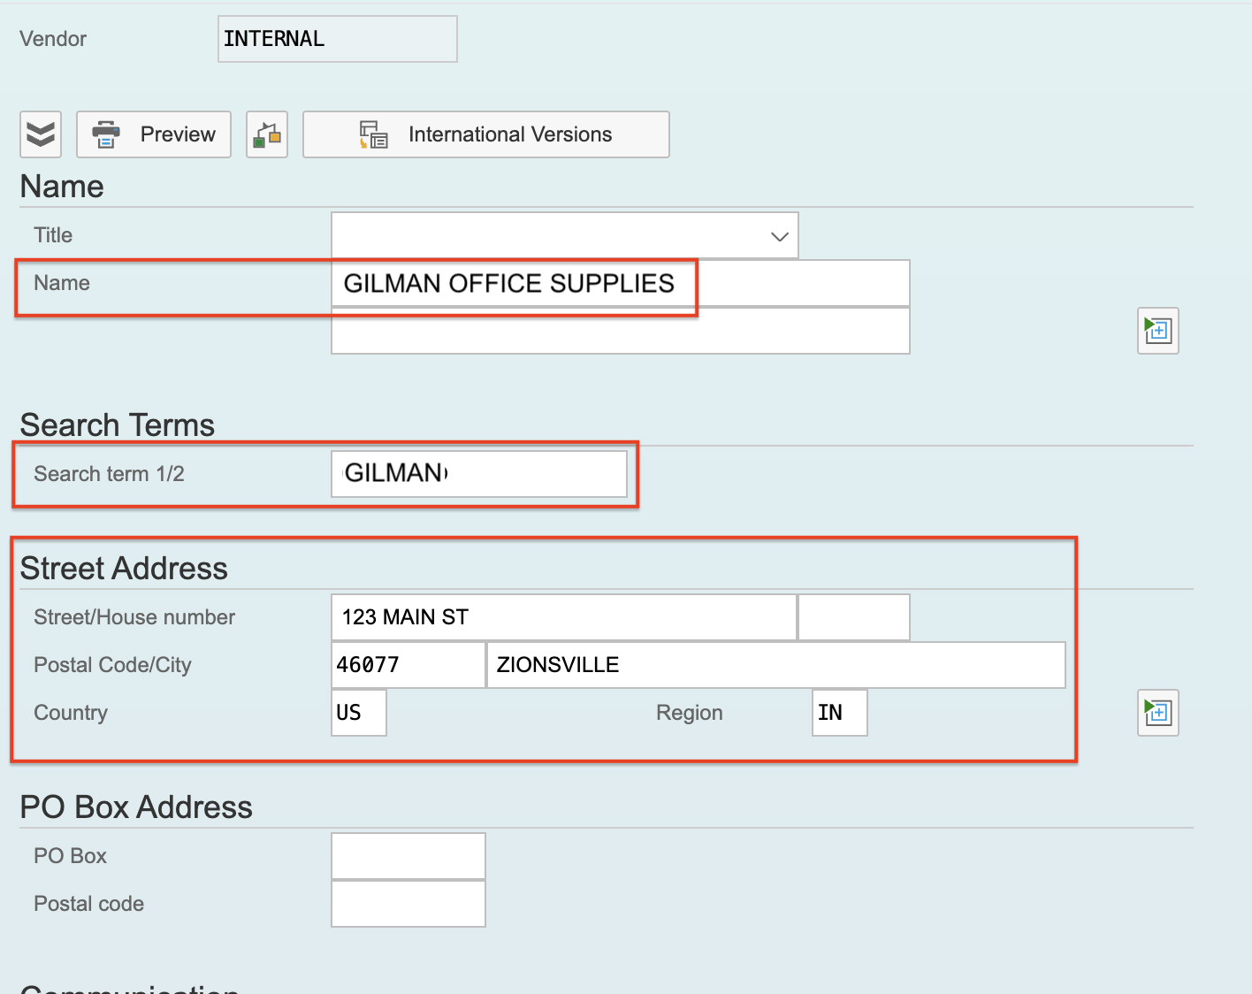

Skip the next screen by simply hitting **Enter**:

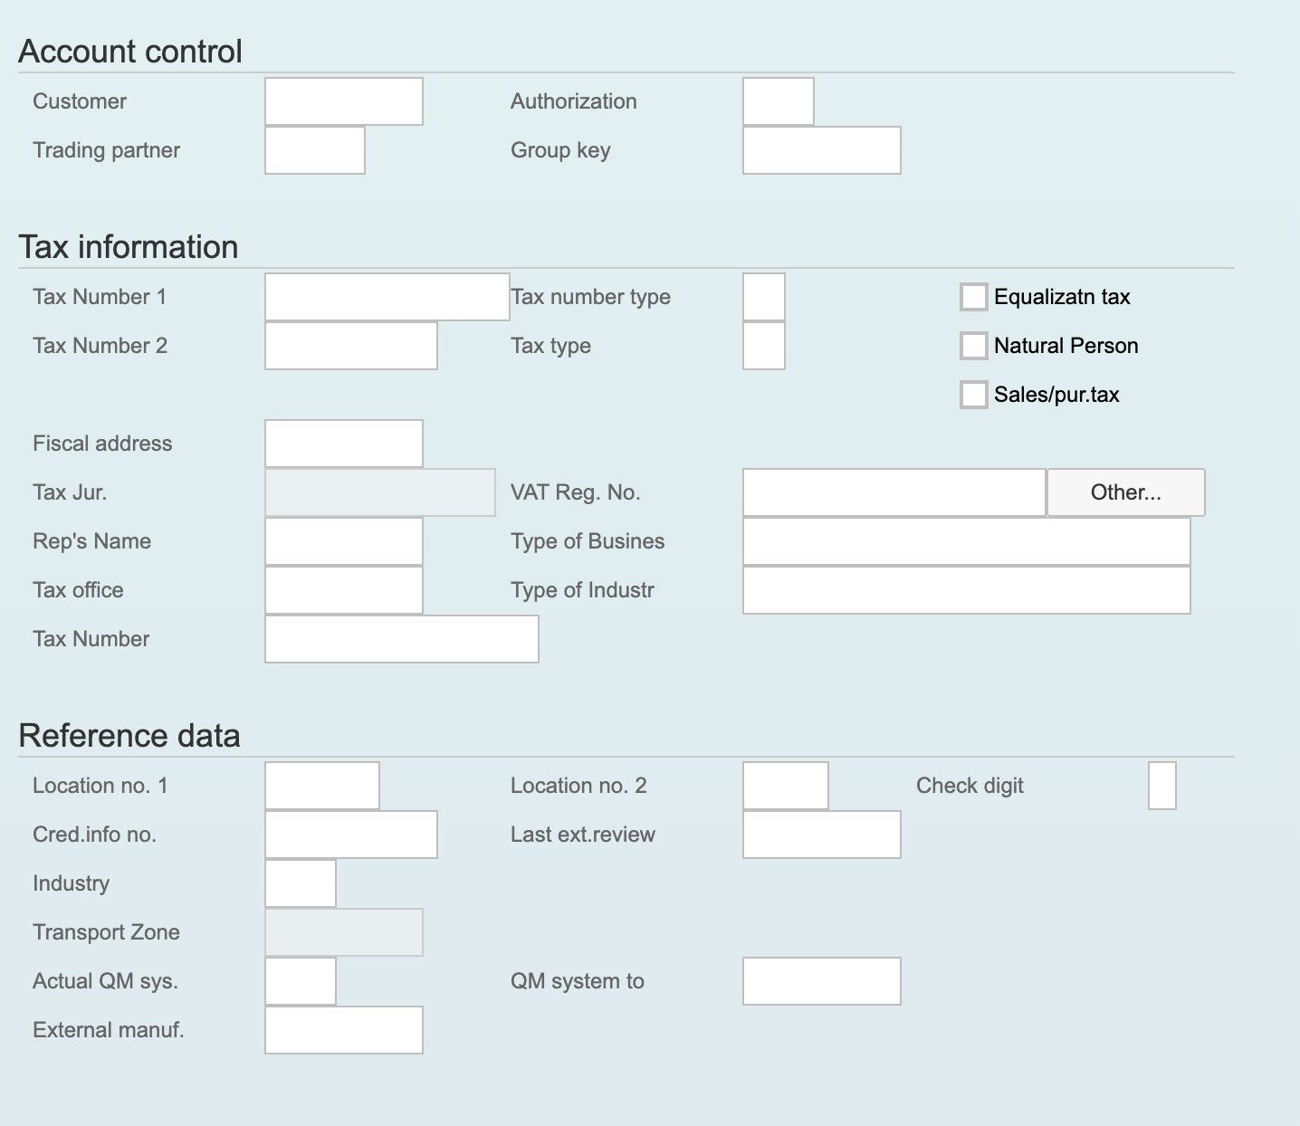

Skip the next screen by simply hitting **Enter**:

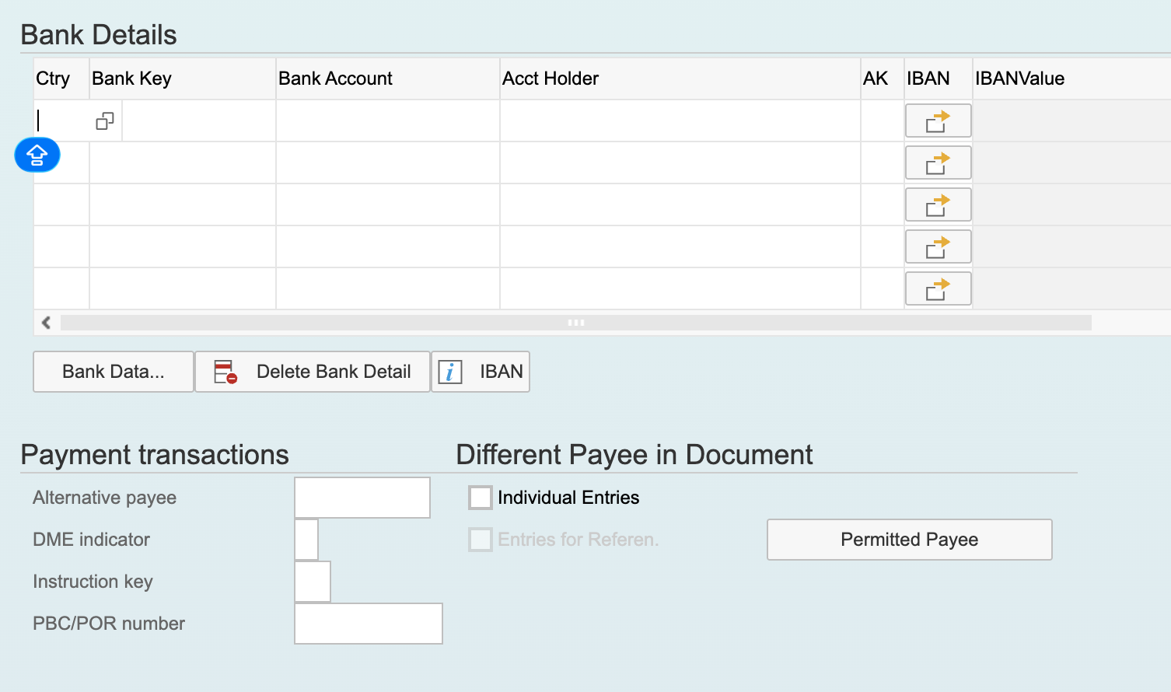

On the screen that displays next, key in yourself as a **Contact Person** and then hit **Enter**:

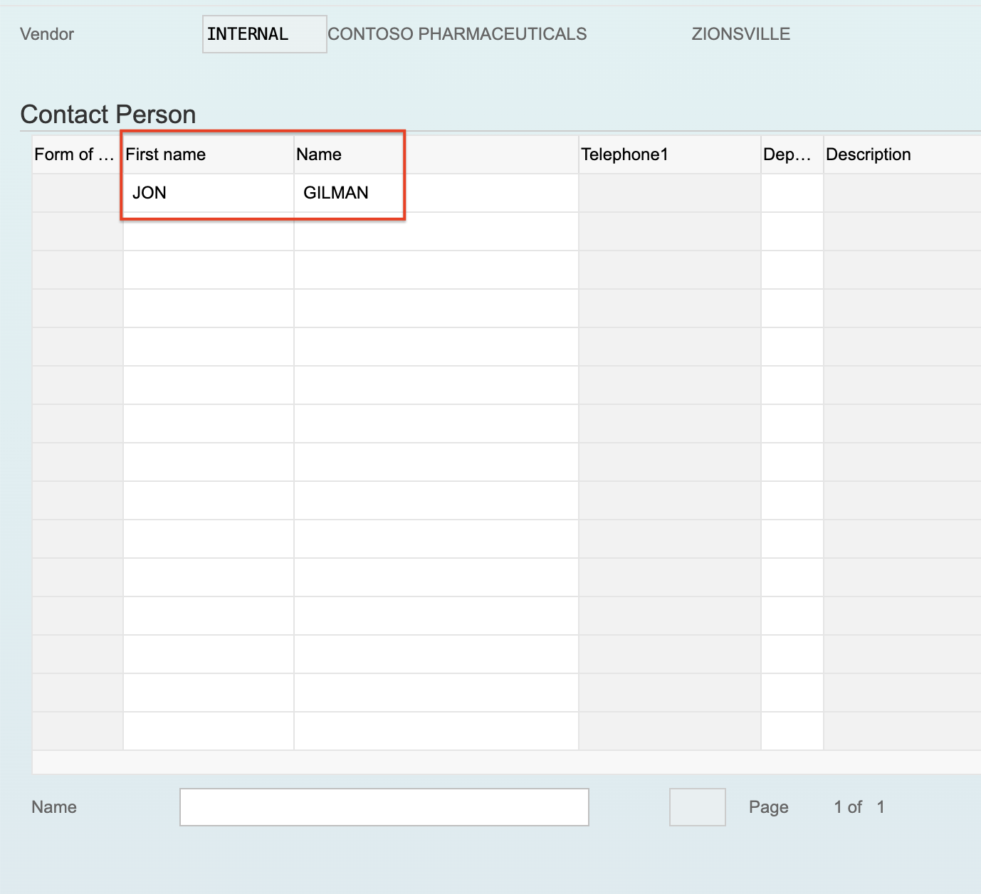

On the screen that displays next, select the following values and then hit **Enter**:

* **Reconciliation Account** – click in the field, press F4, and select **164003**
* **Cash Management Group** – click in the field, press F4, and select **A1**

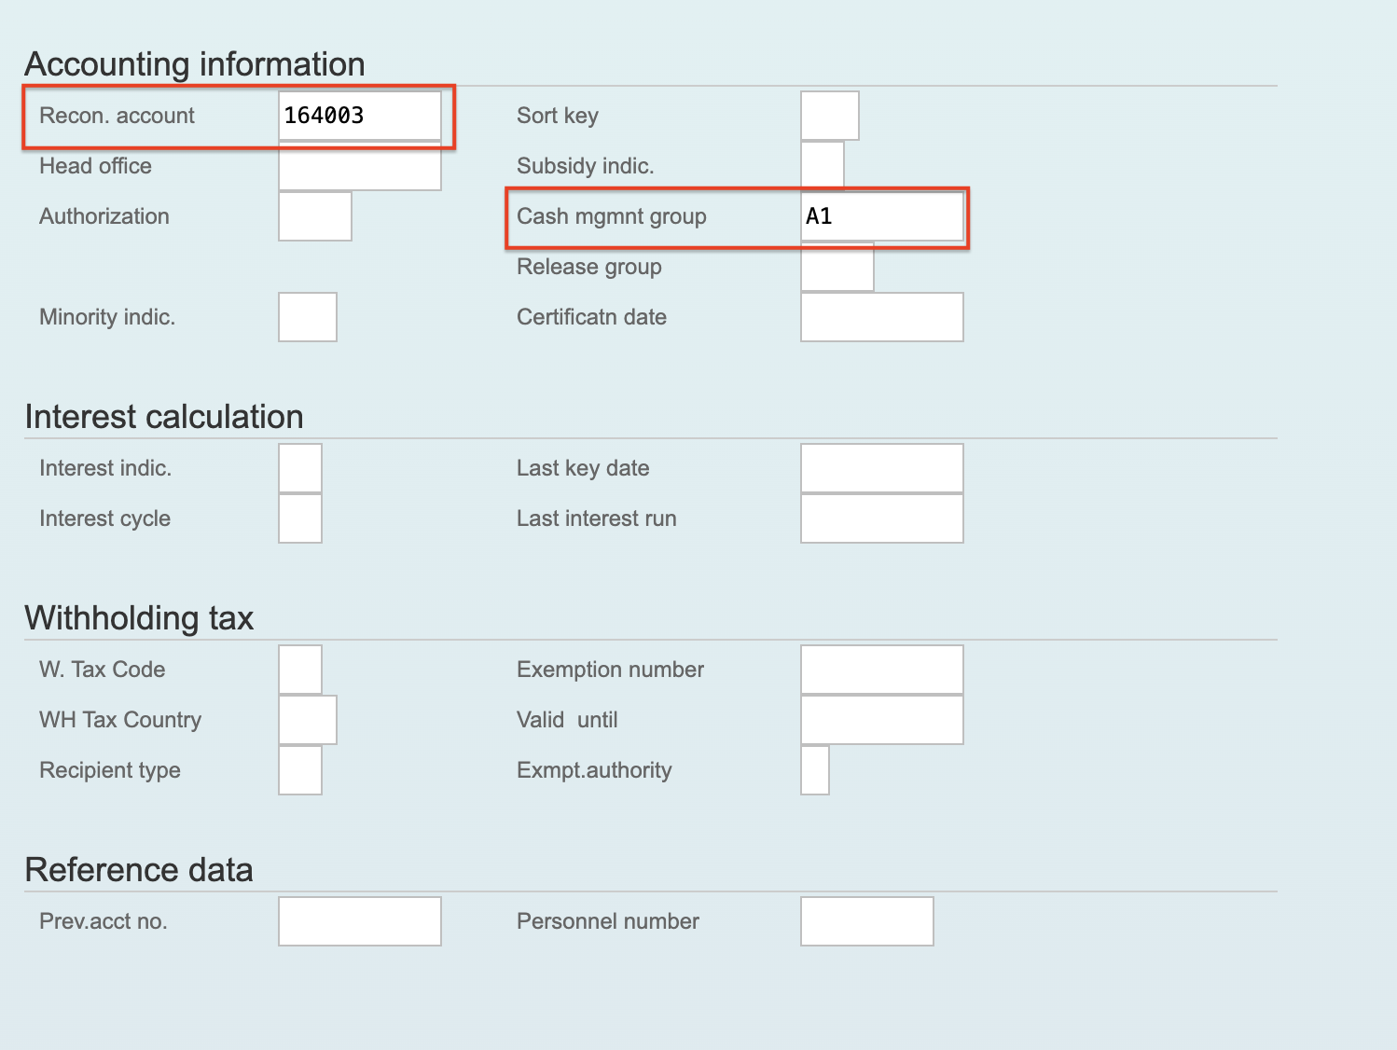

On the screen that displays next, select the following values and then hit **Enter**:

* **Payment Terms** – click in the field, press F4, and select **0001**

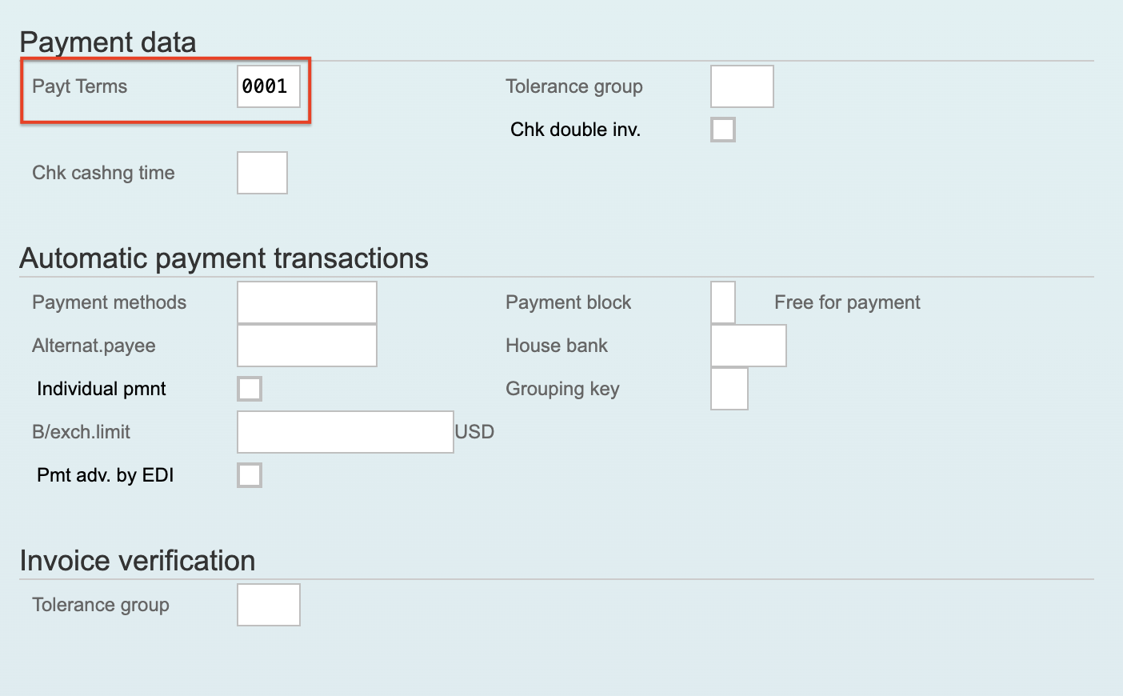

Skip the next screen by simply hitting **Enter**:

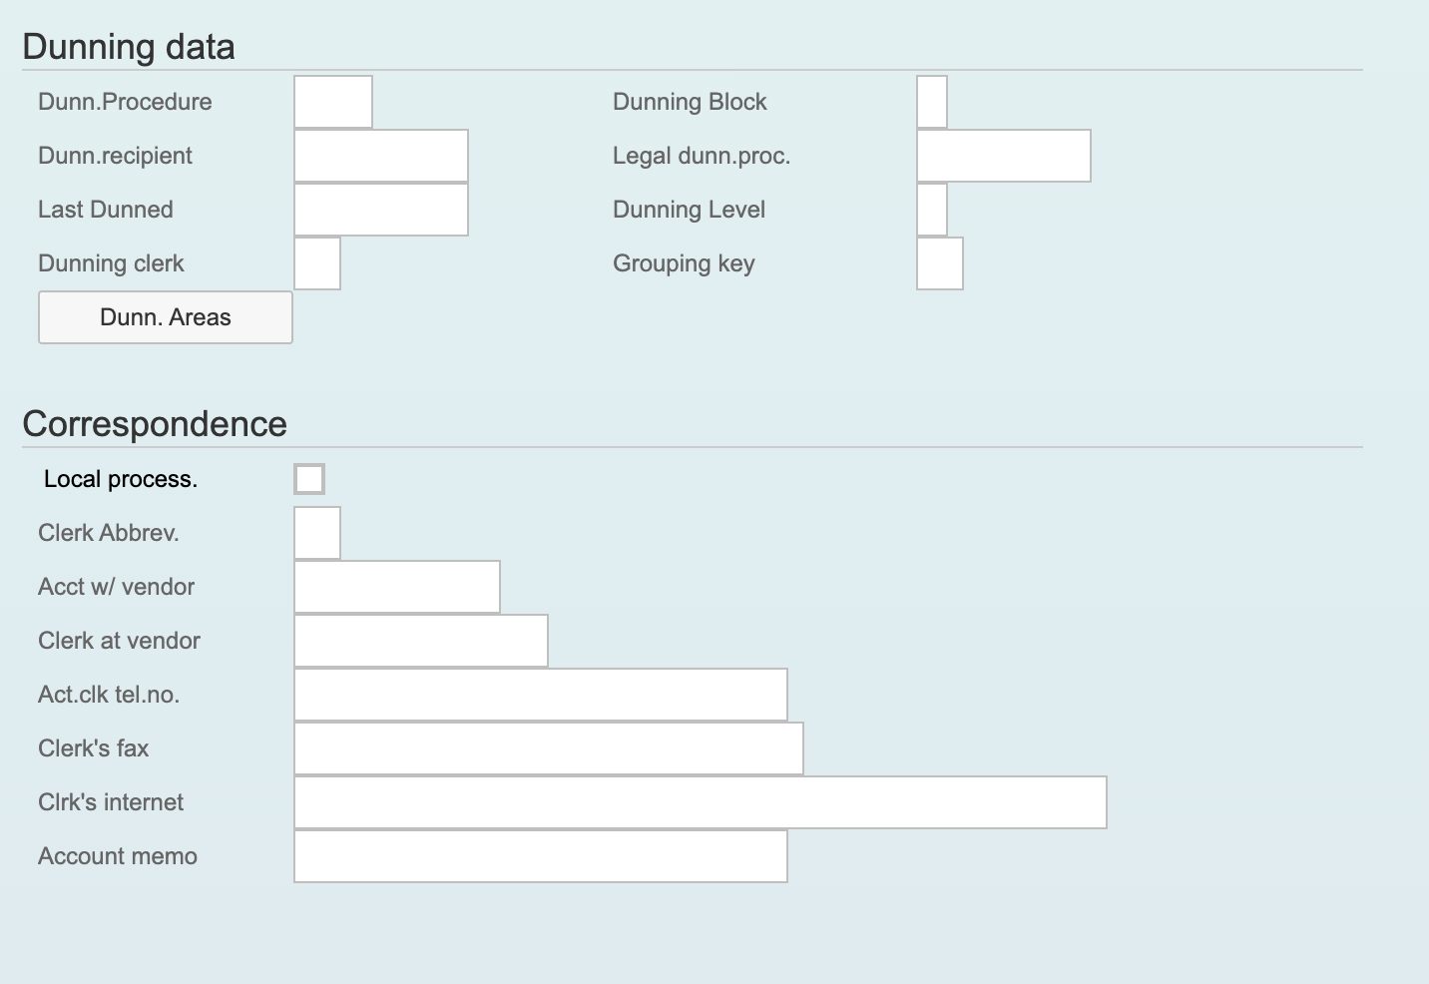

On the screen that displays next, select the following values and then hit **Enter**:

* **Order Currency** – click in the field, press F4, and select **USD**
* **Payment Terms** – click in the field, press F4, and select **0001**

Skip the next screen by simply hitting **Enter**:

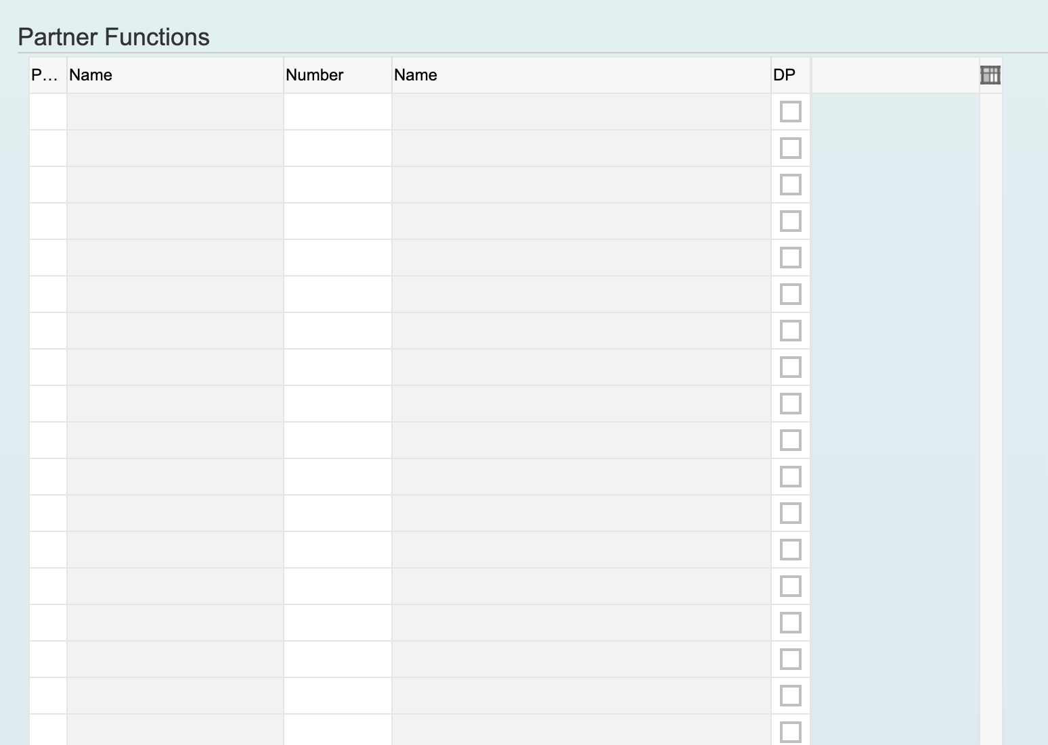

You will be prompted to save the new vendor. Click **Yes**:

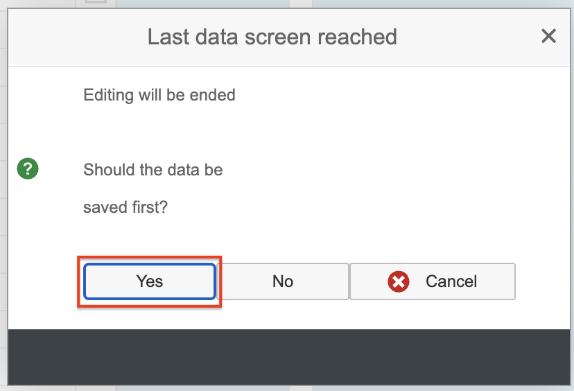

In the lower left corner of the screen, a message will appear with your new vendor number. Write it down for subsequent exercises:

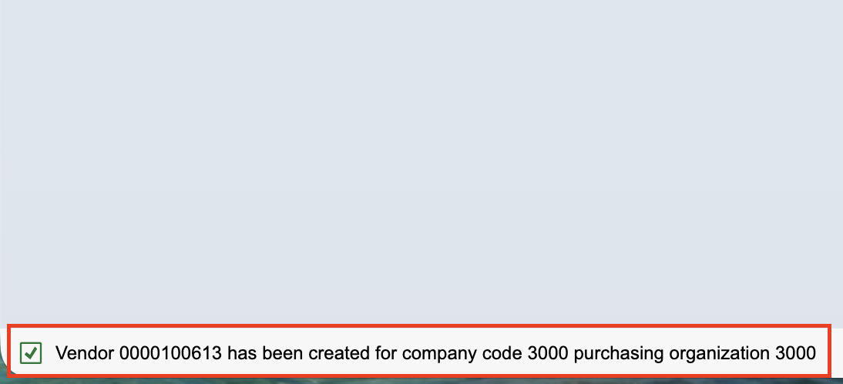

# Exercise 3 - Create a Purchase Order

After creating your vendor, you can navigate to the Create Purchase Order screen in the upper left corner of the current screen by typing **/nME21N**. ME21N is the transaction code for the Create Purchase Order screen, while the **/n** in front of it is a shortcut in SAP to navigate to a new screen without having to go all the way back to the SAP home screen:

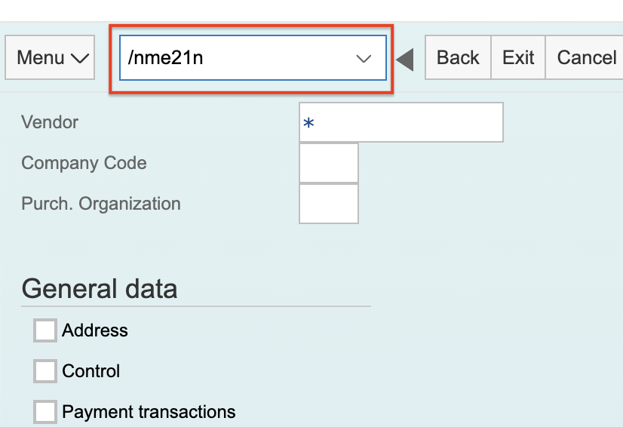

On the screen that displays next, type in the number of the vendor you just created and then hit **Enter**:

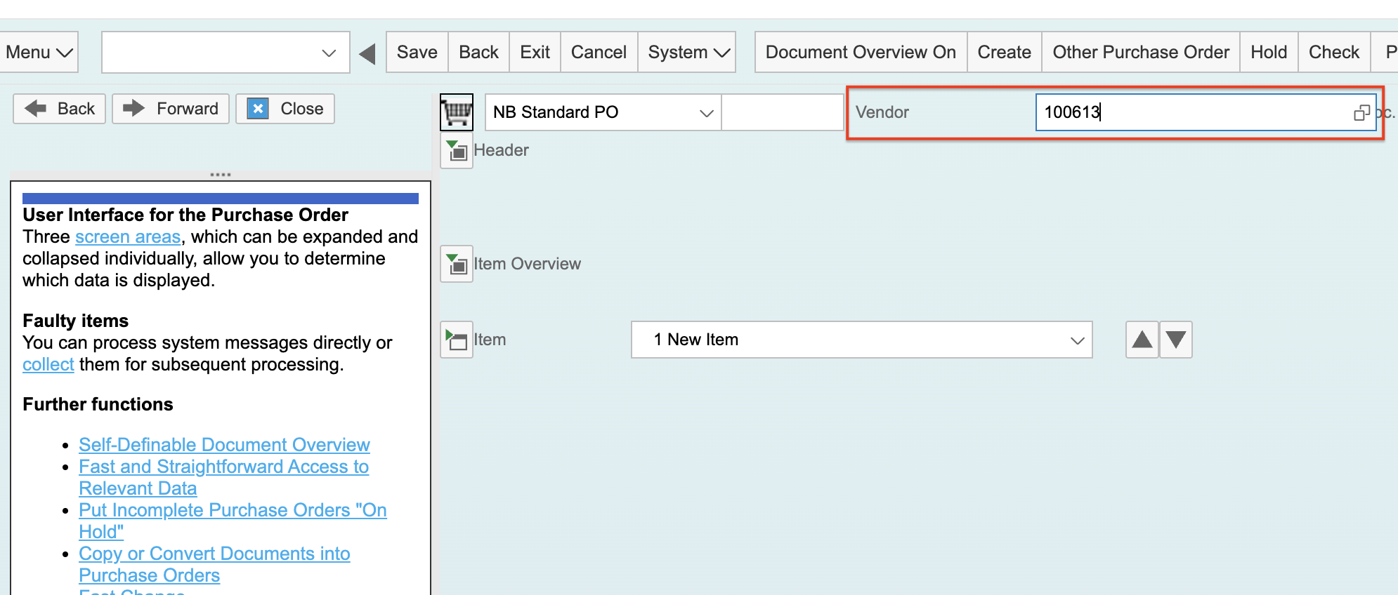

On the screen that displays next, select the following values and then hit **Enter**:

* **Purchasing Organization** – click in the field, press F4, and select **3000**
* **Purchasing Group** – click in the field, press F4, and select **300**
* **Company Code** – click in the field, press F4, and select **3000**

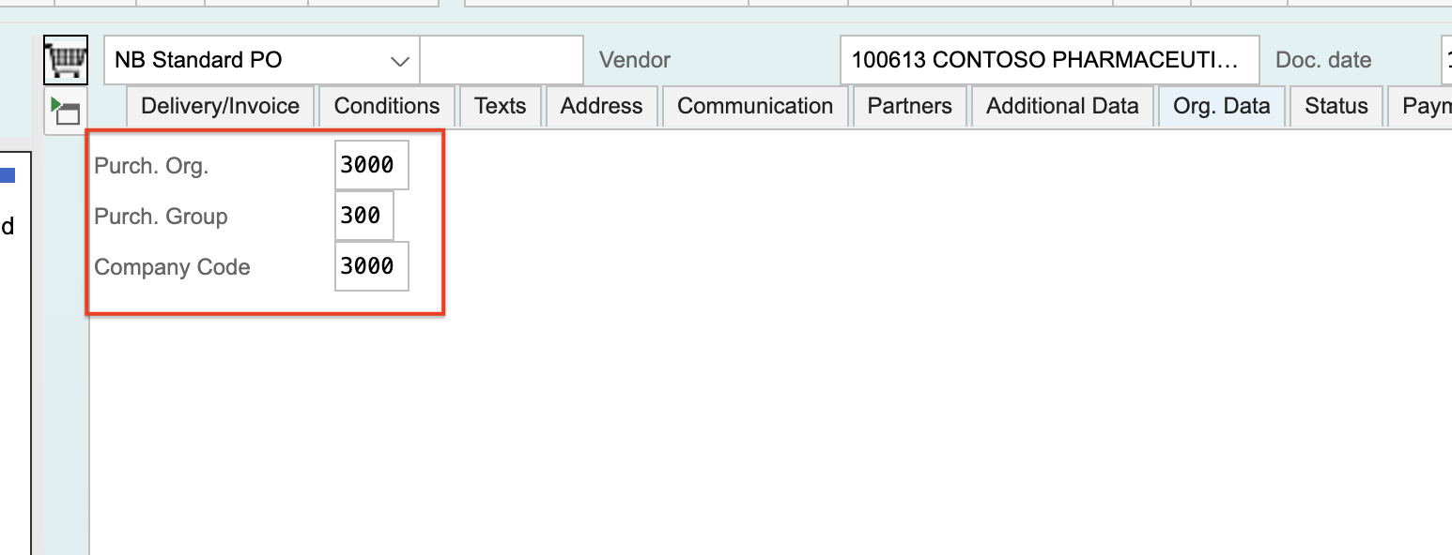

Click on the **Item Overview** button and key in the following values:

* Item – 1, 2, and 3, respectively
* Material – 938 for all 3 items, which is the product code for office supplies in this SAP system
* Short Text – PRINTER, TONER, and PAPER, respectively
* PO Quantity – 1, 4, and 10, respectively
* Net Price – 1000, 100, and 10, respectively
* Plant – 3000 for all 3 items

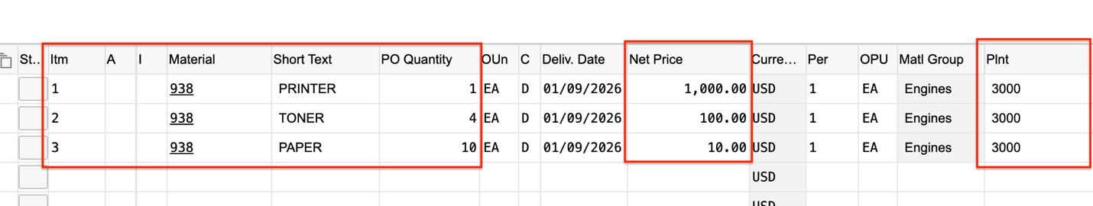

Lastly, click the **Save** button:

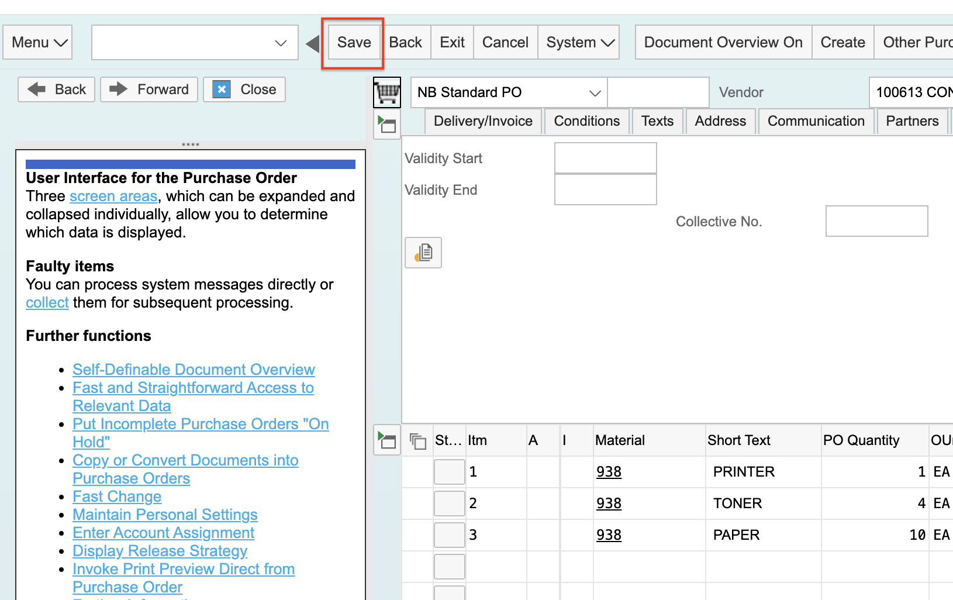

Type **/nME22** in the transaction launcher in the upper left and hit **Enter.** Your purchase order number will appear. Write it down for subsequent exercises:

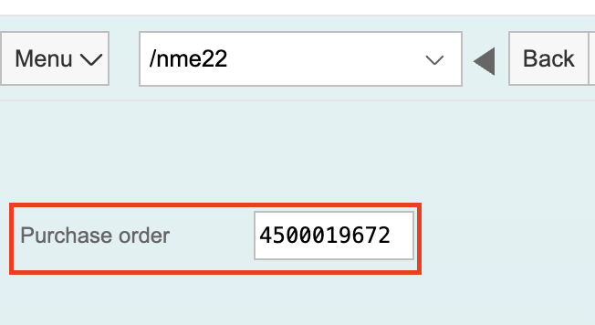

# Exercise 4 - Approve and Release a Purchase Order

Type **/nME29N** in the transaction launch in the upper left and hit **Enter**:

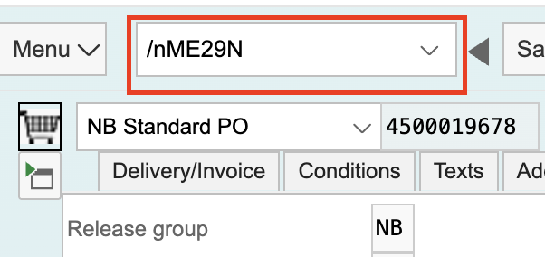

Click on the **Other Purchase Order** button:

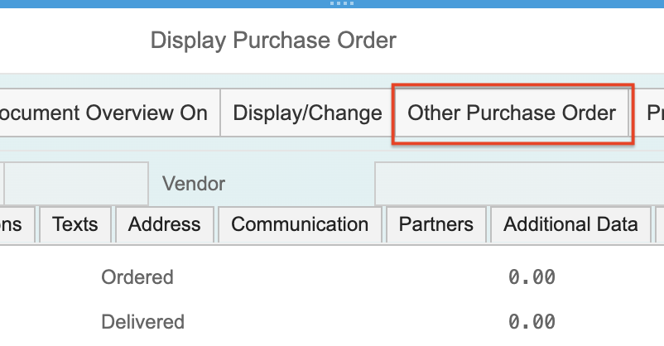

Type in the number of the purchase order you just created and hit **Enter**:

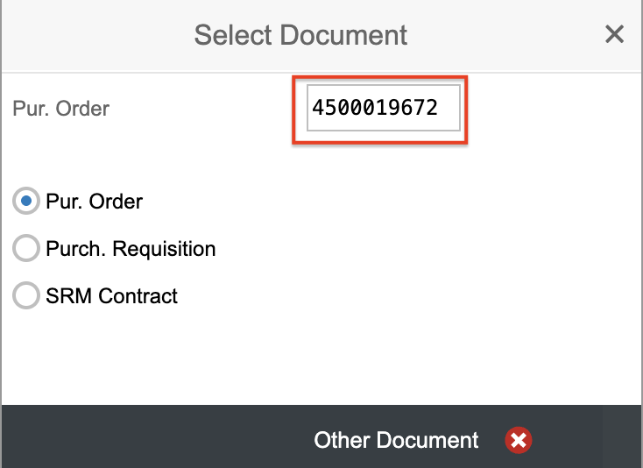

Click on the **Release strategy** tab:

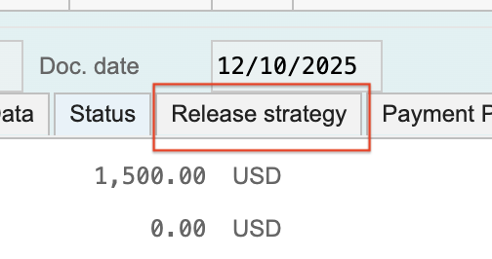

Click on the release icon:

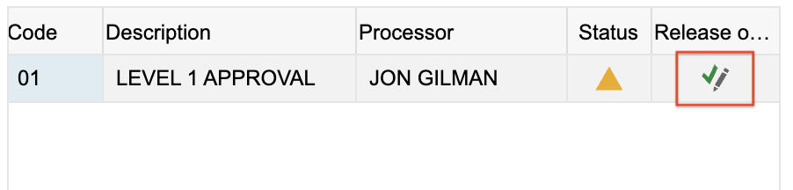

Lastly click the **Save** button:

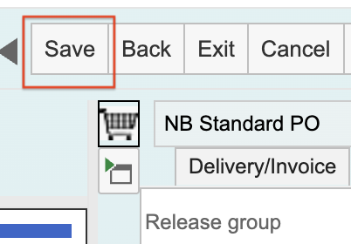

# Exercise 5 - Create a Goods Receipt

After approving your purchase order, you can navigate to the Create Goods Movement screen in the upper left corner of the current screen by typing **/nMIGO**.

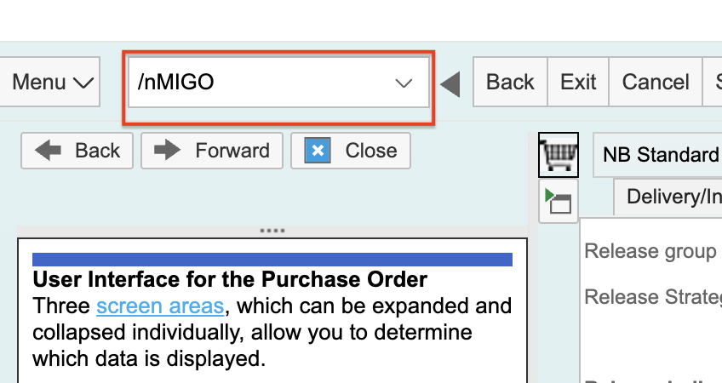

Type in the number of the purchase order you just created and hit **Enter**:

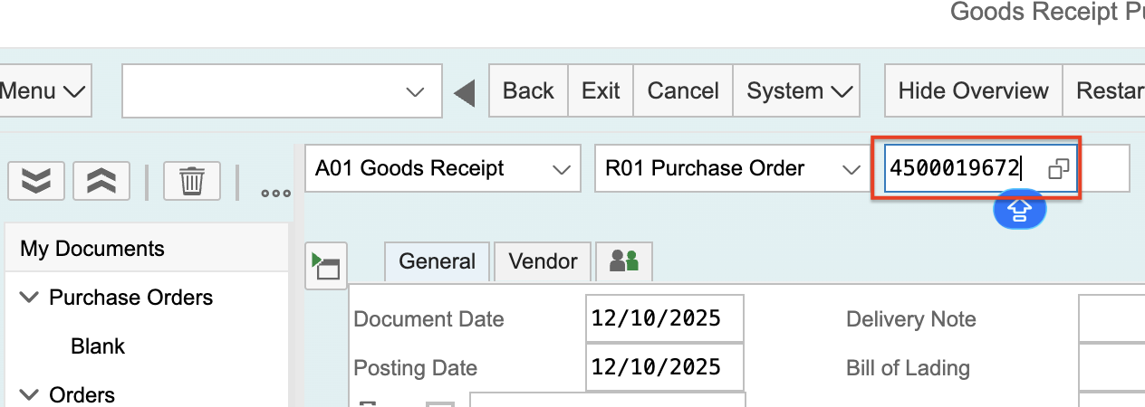

By default, the first row will be greyed out because the Item Detail screen is displayed. Click the collapse button the make the first row editable:

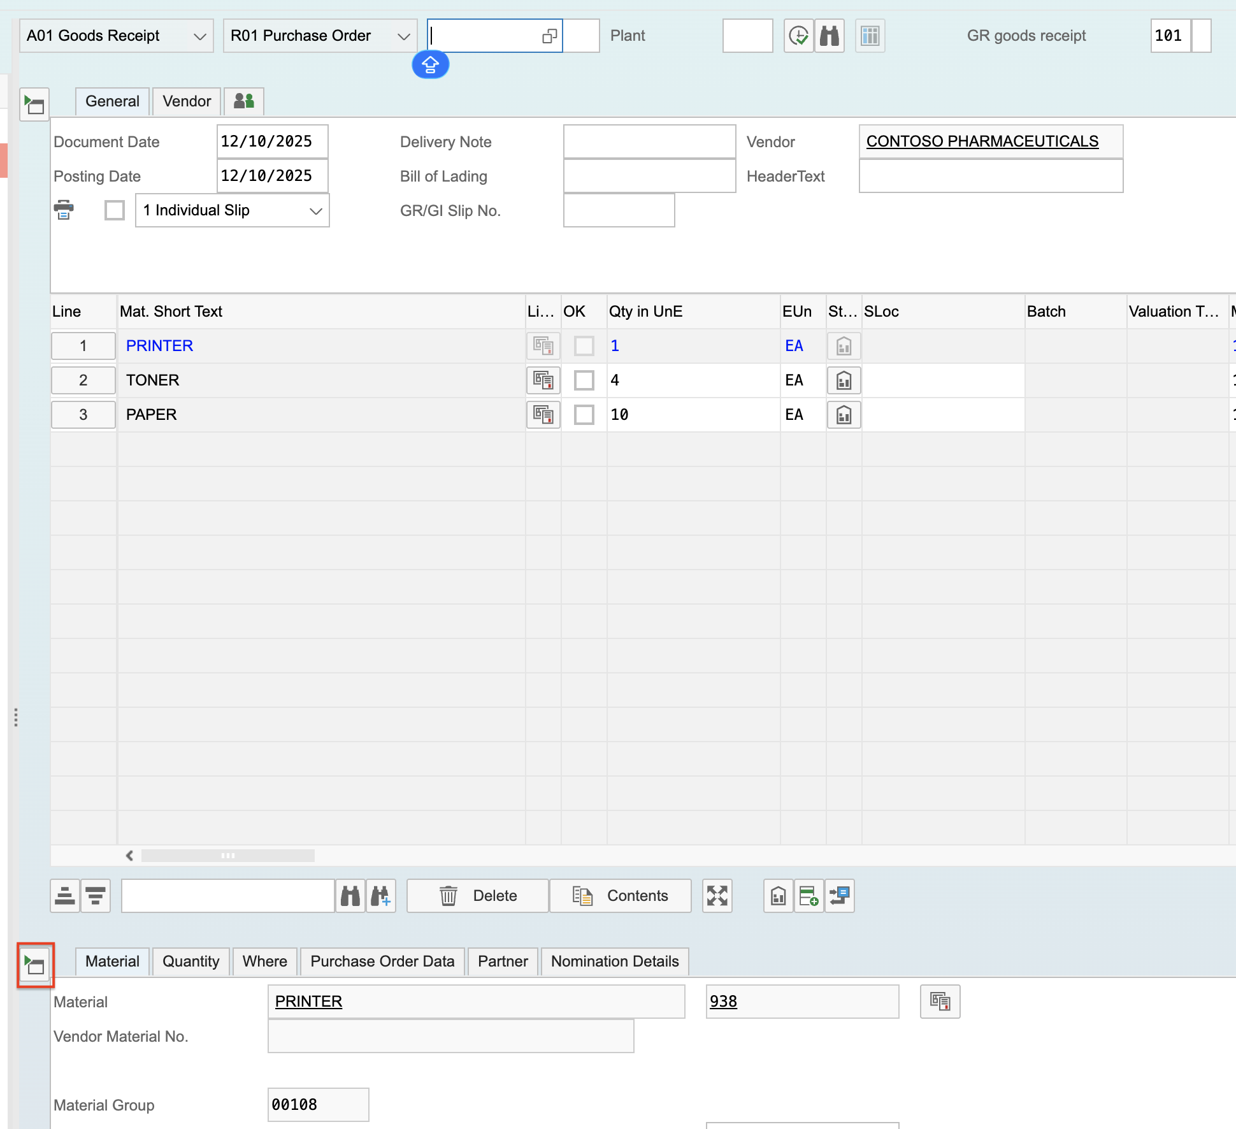

The items from the purchase order will display. Click the **OK** checkbox for each item and type in **ITSW** as the storage location:

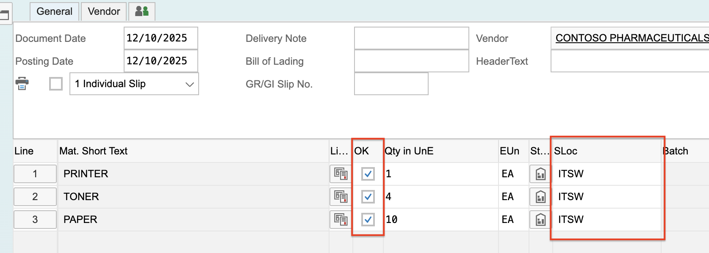

Click the **Post** button:

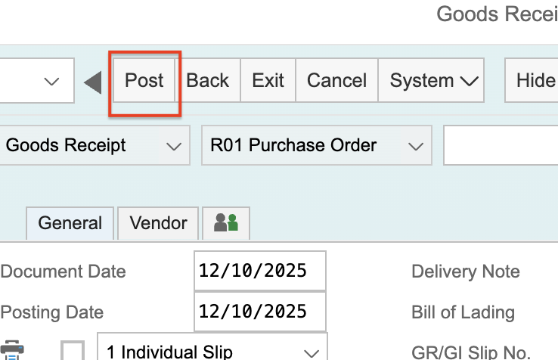

In the lower left corner of the screen, a message will appear with your new goods receipt number. Write it down for subsequent exercises:

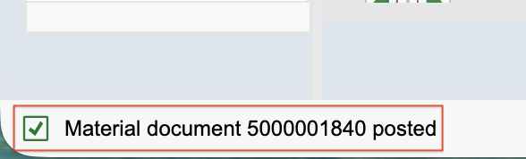

# Exercise 6 - Create a Vendor Invoice

After creating your goods receipt, you can navigate to the Create Vendor Invoice screen in the upper left corner of the current screen by typing **/nMIRO**.

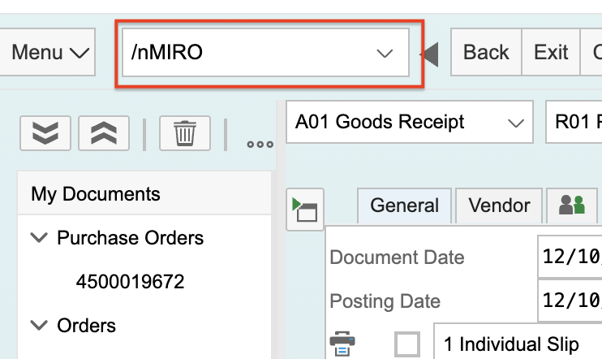

On the screen that displays next, select the following values and then hit **Enter**:

* **Invoice Date** – click in the field, press F4, and select **today’s date**
* **Amount** – type in 1500
* **Purchase Order** – type in your purchase order number

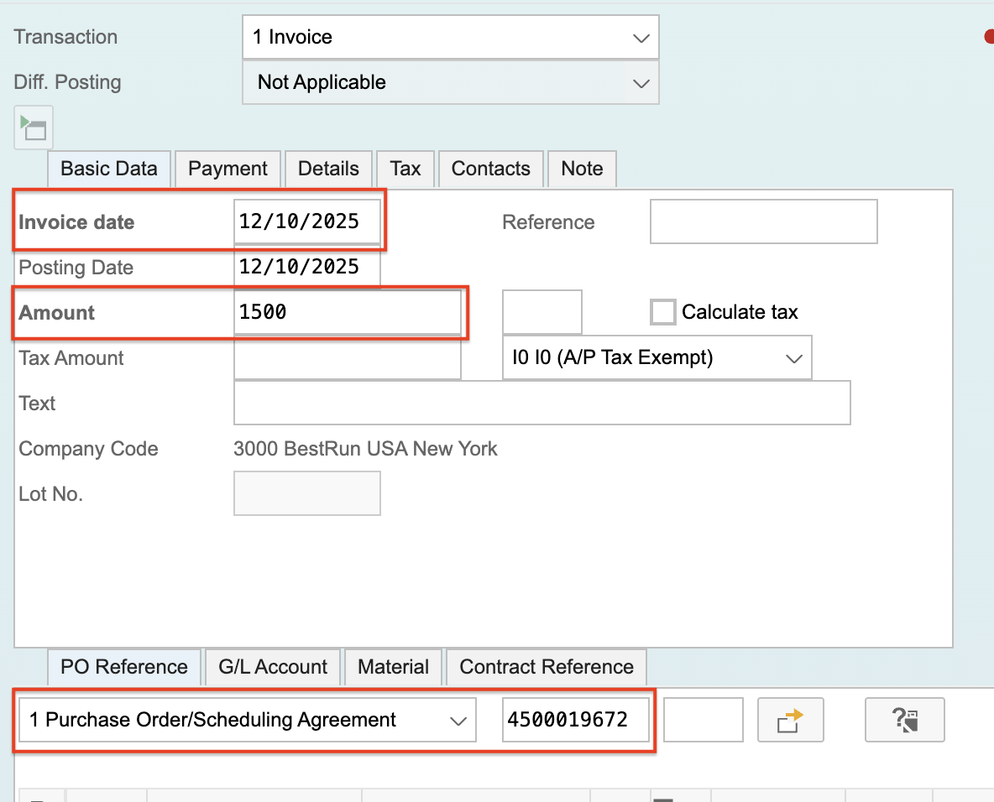

Each of the items will display. Click the checkbox indicating that each item has been matched to your purchase order:

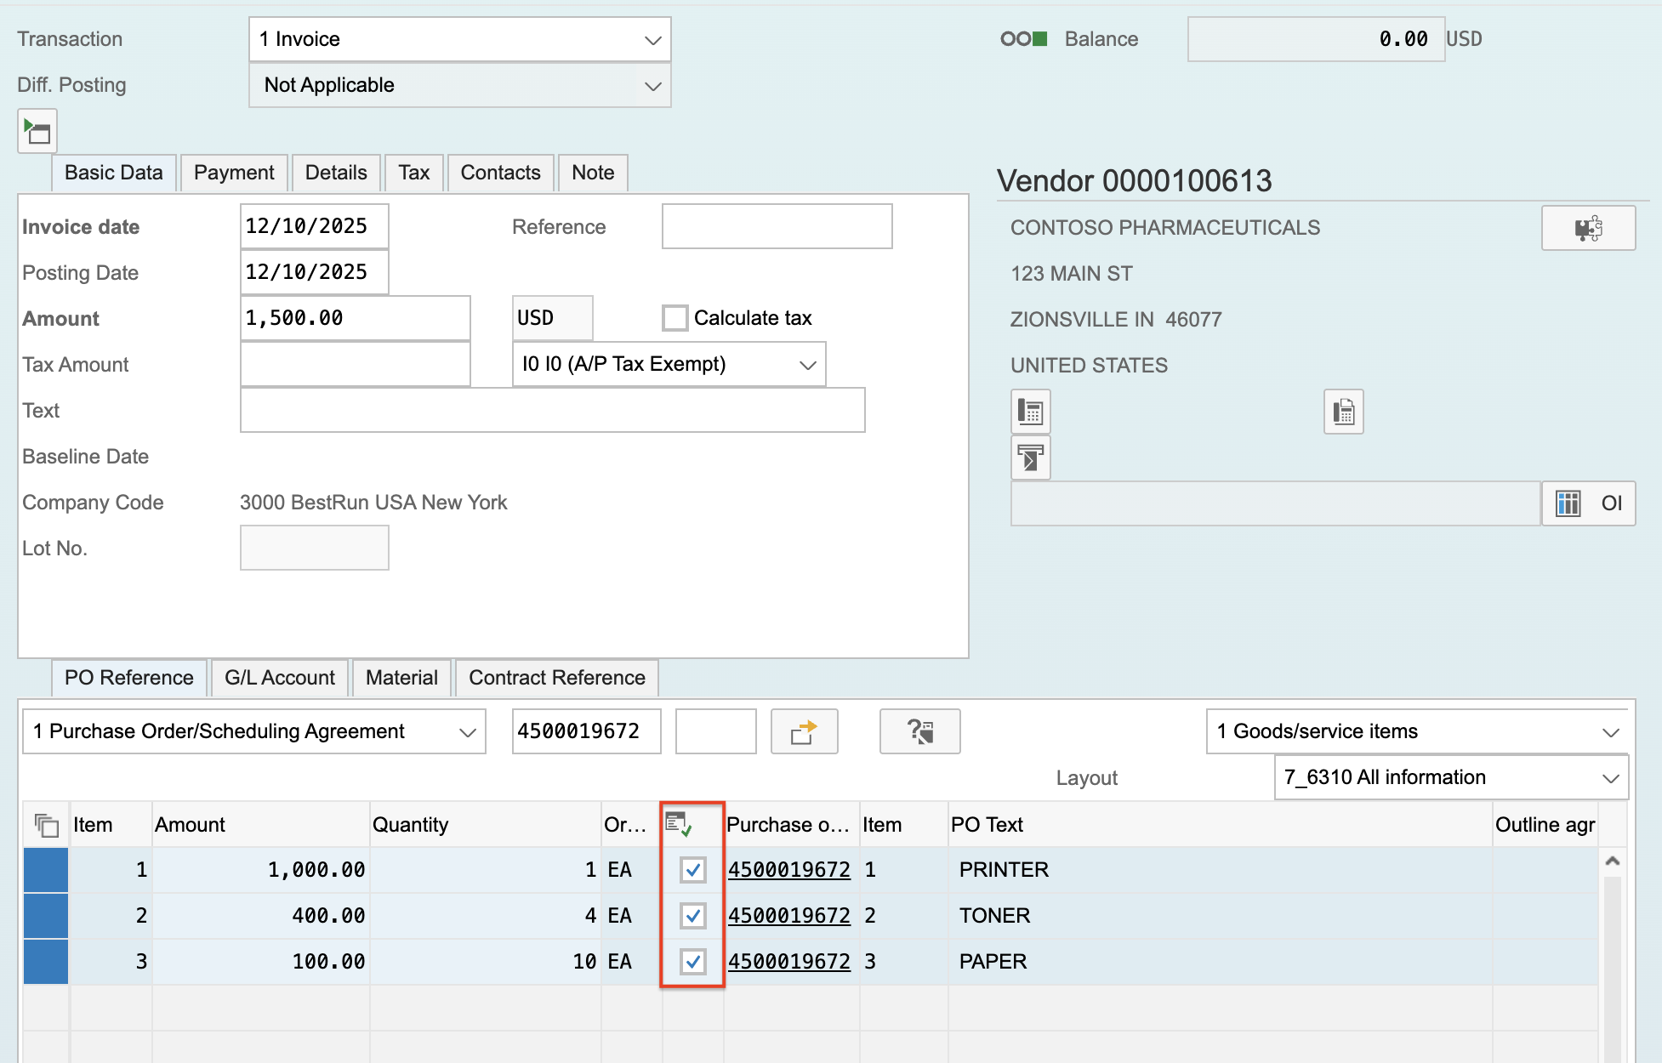

Click on the **Payment** tab, select today’s date for **Baseline Date**, then click the **Post** button:

